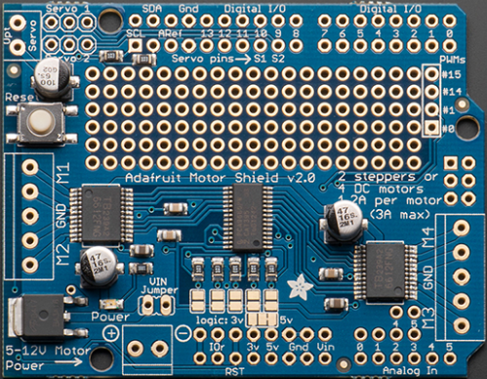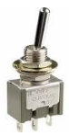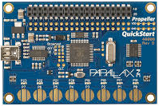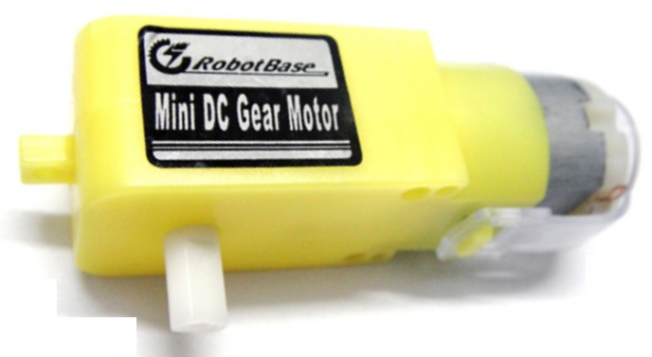

Back Right

Front Right

Back Left

Front Left

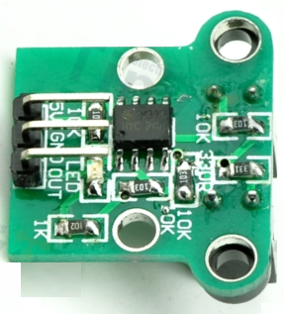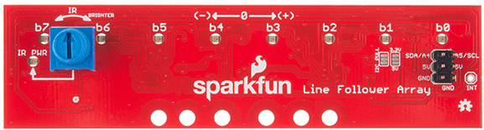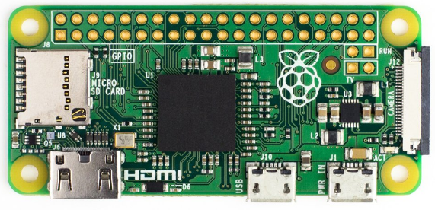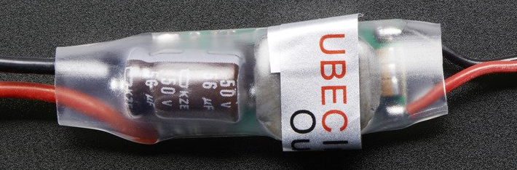

+9.6

+5

+5

+5

+5

+5



+5



UBEC 5V

Adafruit Motor

Propeller

Raspberry Pi ZeroW

Encoder

+5

+3.3



Back Right

Front Right

Back Left

Front Left



+9.6



+5

UBEC 5V

Adafruit Motor

Raspberry Pi ZeroW

+3.3

+5